# Class specifications of some of the classes needed in BuzzThreads

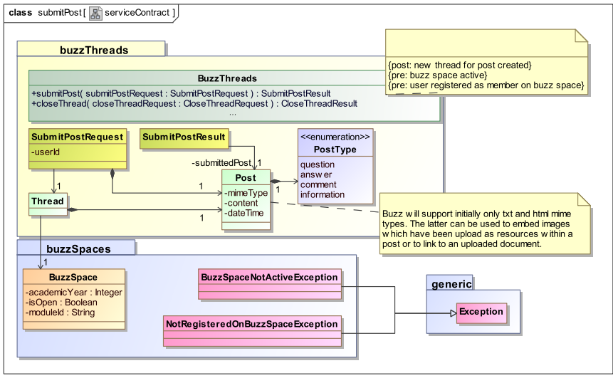

## Class : SubmitPost

#### Variables:

##### To be included

#### Functions:

##### SubmitPost(submitPostRequest:SubmitPostRequest): SubmitPostResult

* + - * 1. Receives a **SubmitPostRequest** object which contains relevant information (See **SubmitPostRequest** class specification) .
        2. Submits a post to a thread, creating a child thread
        3. Returns a **SubmitPostResult** which contains the results of the operation(See **SubmitPostResult** class specification)

##### closeThread(closeThreadRequest: CloseThreadRequest): CloseThreadResult

* + - * 1. Receives a **CloseThreadRequest** object which contains relevant information (See **CloseThreadRequest** class specification) ..
        2. Returns a **CloseThreadResult** which contains the results of the operation(See **CloseThreadResult** class specification)

## Class: SubmitPostRequest

#### Variables:

##### UserId : Id

1. User Id of the user who owns the requested post.

##### post :Post

1. A handle to the post that contains information

##### ThreadId: Id

1. Thread that the post should be submitted too and through this the buzz space in which the user is posting to.

#### Functions:

*Suggested Functions

##### GetUserId(): userId

1. Returns the post owner’s Id

##### SetUserId:Void

1. Sets the userId variable

##### SetPost(post: Post):void

1. Set the post variable

##### getPost():Post

1. Gets the post variable.

##### SetThreadId(Id: ThreadId):void

1. Set the thread Id in which a post will belong to.

##### getThread():ThreadId

1. Gets the Thread variable.

## Class: Post

#### Variables:

##### Content

1. Contains the actual content which is an enumeration

##### Enumerations : PostType

* + - * + Question
        + Answer
        + Comment
        + Information

##### Mimetype

* + - * 1. Specifies the content type : txt or html

##### dateTime

1. date and time the post was made.

#### Functions:

*Suggested Functions

##### GetContent(): Content

1. Returns an object which holds the actual content.

##### SetContent(content : Content):Void

1. Sets the content variable

##### SetMimeType(mimeType: MimeType):void

1. Set the mimetype variable

##### getMimeType():Mimetype

1. Gets the mimetype variable.

##### SetDateTime (dateTime: DateTime):void

1. Set the thread Id in which a post will belong to.

##### getDateTime():DateTime

1. Gets the dateTime variable.

### Class: Thread

Note: I am not sure of these member variables and functions. Should ask Hugo..

#### Variables:

##### SpaceIdentificationID

1. Holds the id to the space in which the thread belongs to.

##### ThreadId

1. Id to specify this thread.

##### Post

1. A handle to the post that is contained within this thread.

#### Functions:

*Suggested Functions

##### GetSpaceIdentifcationId():SpaceIdentificationID

1. Return and Id to which the current thread belongs to.

##### SetSpaceIdentifcationId (SpaceIdentificationid:SpaceIdentificationID):Void

1. Sets the SetSpaceIdentifcationId variable

##### SetPost(post: Post):void

1. Set the post variable

##### getPost():Post

1. Gets the post variable.

##### SetThreadId(Id: ThreadId):void

1. Set the this thread id

##### getThread():ThreadId

1. Gets this thread id

## Class: MarkPostAsRead

#### Variables:

##### To be included

#### Functions:

##### MarkPostAsRead (markPostAsReadRequest: MarkPostAsReadRequest): MarkPostAsReadResult

* + - * 1. Receives a markPostAsReadRequest object which contains relevant information (See **markPostAsReadRequest** class specification) .
        2. Returns a **MarkPostAsReadResult** which contains the results of the operation(See **MarkPostAsReadResult** class specification)

## Class: MarkPostAsReadRequest

#### Variables:

##### To be included

#### Functions:

To be include

## Class: MarkPostAsReadResults

#### Variables:

##### To be included

#### Functions:

To be included

## Class: ReadingEvent

#### Variables:

##### dateTime

* Contains the date and time in which a post was read.

#### Functions:

To be included

## Class: CloseThread

#### Variables:

To be included

#### Functions:

##### CloseThread(closeThreadRequest : CloseThreadRequest):CloseThreadResult;

* + - * 1. Receives a CloseThreadRequest object which contains relevant information (See **CloseThreadRequest** class specification) .
        2. Returns a **CloseThreadResult** which contains the results of the operation(See **CloseThreadResult** class specification)

## Class: CloseThreadRequest

#### Variables:

##### To be included

#### Functions:

To be included

## Class: CloseThreadResults

#### Variables:

##### To be included

#### Functions:

To be included